L05_Hillary_Dreyer Bruton_ITAI2372

Proof of Completed Lab:

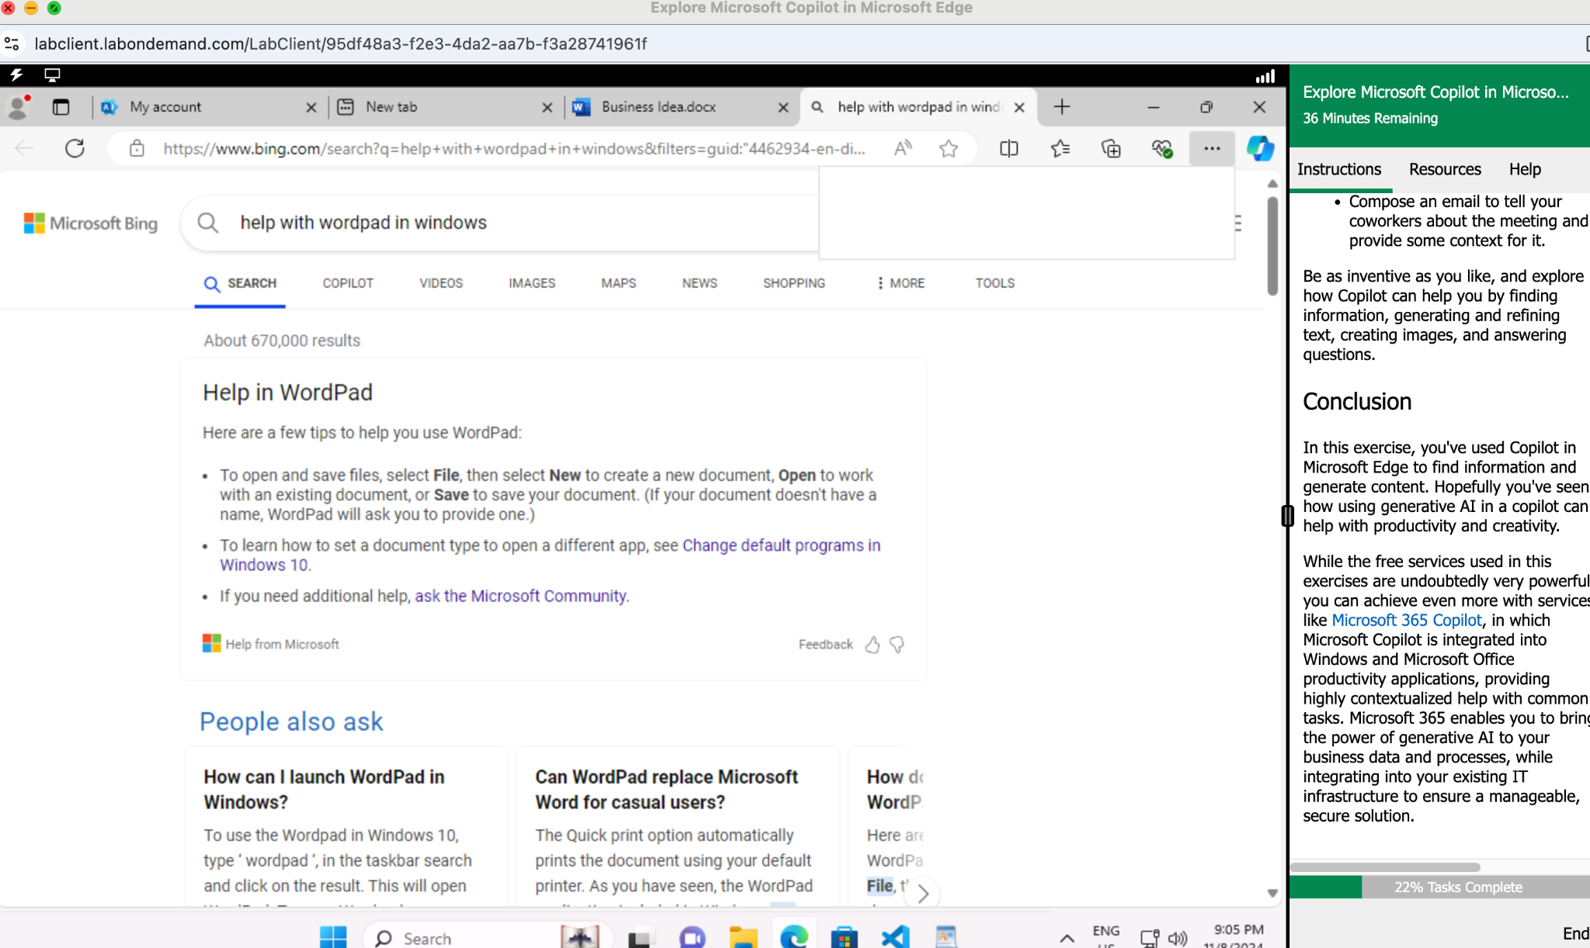

Lab 05 Reflective Journal:

What did I learn?

In this lab, I discovered how Copilot uses gen AI to speed up content creation, specifically using the example of new business ventures. Beginning with just a basic description of notes for a business idea, Copilot assisted in creating a full-fledged business plan, complete with financials.

The exercise went beyond the presentation and demonstrated how Copilot could create a pre-read document and compose and email to accompany the materials in the “Challenge” section.

While I am very familiar with gen AI tools similar to Copilot, I appreciated the ease of use within the same program instead of going out of the app to find solutions and help.

What were the challenges I faced?

The main challenge I encountered while trying to complete Lab 05 was the inability to access the Copilot pane within Edge as the lab instructions indicated. This prevented me from utilizing the lab to understand Copilot. Clicking “Edit a Copy” resulted in a Microsoft Word error related to saving the file to OneDrive, causing a stall out in lab progression.

Despite these obstacles, I continued to research Copilot online as I reviewed lab instructions to understand the training’s intended goals and outcomes. This allowed me to gain some knowledge of Copilot’s capabilities, even if I couldn’t experience them as the lab intended.

What insights were gleaned?

I found that the workflow for Copilot could make the use of gen AI a more seamless experience rather than relying upon the gen AI alternatives from other sources. That said, I question the robustness of Copilot and its models so as not to rely upon it as a end-all be-all solution. Used in combination with other resources, however, I am certain that Copilot will provide tons of value for more mundane tasks, especially in areas like business communications.